Market Based Sustainability Credits for Dietary Shifts
Amith N, Harrison Vincent, Keertan Reddy
2026-06-26

Trend of Meat Consumption
# Aggregate yearly meat consumption
meat_trend <- aggregate(
Value ~ Year,
data = meat,
FUN = sum,
na.rm = TRUE
)
plot(
meat_trend$Year,
meat_trend$Value,
type = "o",
lwd = 2,
pch = 16,
col = "darkred",
xlab = "Year",
ylab = "Food Supply (kg/capita/year)",
main = "Trend of Meat Consumption in Asia (2010–2025)"
)
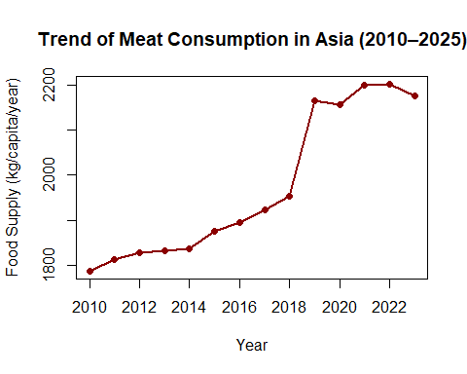
Interpretation
The graph illustrates the trend in per-capita meat consumption across Asia between 2010 and 2025. An upward trend indicates increasing demand for meat products over time, which may be attributed to population growth, rising incomes, urbanization, and changing dietary preferences.

Trend of Livestock Methane Emissions
ghg_trend <- aggregate(
Emission ~ Year,
data = ghg,
FUN = sum,
na.rm = TRUE
)
plot(
ghg_trend$Year,
ghg_trend$Emission,
type = "o",
lwd = 2,
pch = 16,
col = "blue",
xlab = "Year",
ylab = "Methane Emissions",
main = "Agricultural Greenhouse Gas Emissions (CH4)"
)
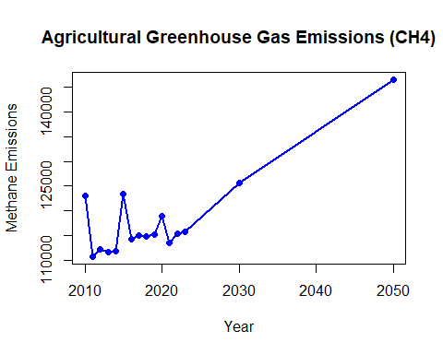
Interpretation
This graph shows the annual trend of livestock methane emissions across Asia. Increasing emissions generally indicate expansion of livestock production and increasing environmental impacts.

Relationship Between Meat Consumption and Methane Emissions
# Aggregate meat by country and year
meat_area <- aggregate(
Value ~ Area + Year,
data = meat,
FUN = sum,
na.rm = TRUE
)
names(meat_area)[3] <- "Meat"
# Aggregate emissions by country and year
ghg_area <- aggregate(
Emission ~ Area + Year,
data = ghg,
FUN = sum,
na.rm = TRUE
)
# Merge datasets
combined <- merge(
meat_area,
ghg_area,
by = c("Area", "Year")
)
# Scatter plot
plot(
combined$Meat,
combined$Emission,
pch = 16,
col = "darkgreen",
xlab = "Meat Consumption (kg/capita/year)",
ylab = "Livestock CH4 Emissions",
main = "Relationship Between Meat Consumption and Agricultural Emissions"
)
# Linear regression
model <- lm(Emission ~ Meat, data = combined)
abline(model, col = "red", lwd = 2)
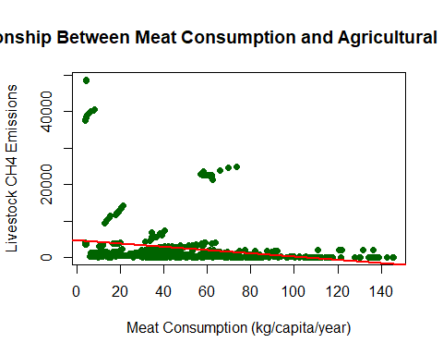
# Optional correlation
cor(combined$Meat, combined$Emission, use = "complete.obs")
## [1] -0.197862
summary(model)
##
## Call:
## lm(formula = Emission ~ Meat, data = combined)
##
## Residuals:
## Min 1Q Median 3Q Max
## -4124 -2808 -1542 -270 44384
##
## Coefficients:
## Estimate Std. Error t value Pr(>|t|)
## (Intercept) 4595.354 486.073 9.454 < 2e-16 ***
## Meat -44.801 8.986 -4.985 8.07e-07 ***
## ---
## Signif. codes: 0 '***' 0.001 '**' 0.01 '*' 0.05 '.' 0.1 ' ' 1
##
## Residual standard error: 6819 on 610 degrees of freedom
## Multiple R-squared: 0.03915, Adjusted R-squared: 0.03757
## F-statistic: 24.85 on 1 and 610 DF, p-value: 8.069e-07
Interpretation
Each point represents a country-year observation. The fitted regression line summarizes the relationship between meat consumption and methane emissions. A positive slope suggests that higher meat consumption is generally associated with higher livestock methane emissions.

